Chapter 1

Enclosure and the Landscape

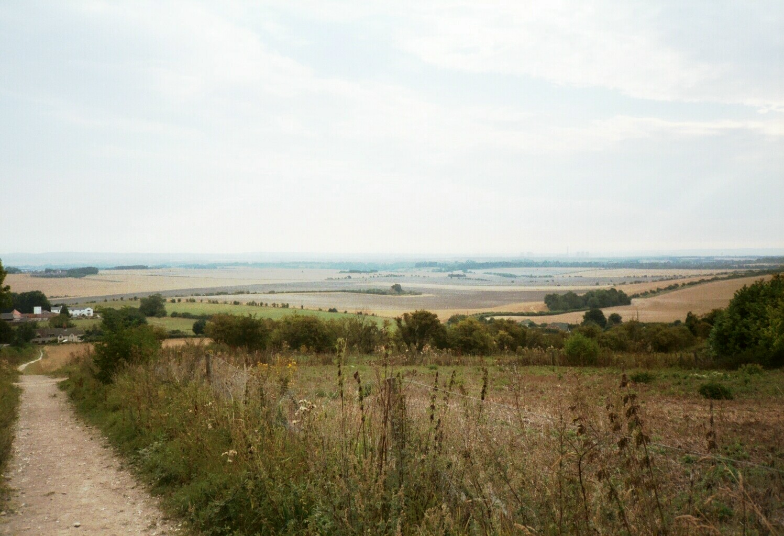
Parliamentary enclosure was one of the most significant events of the eighteenth and nineteenth centuries in any parish in which it occurred. It had an impact on all aspects of the community. It affected the economy. The cost of enclosure was sufficiently great to tie up capital for years, but at the same time, it was carried out in the expectation of increased productivity and profits through improved and more efficient husbandry. It altered the social balance of the community. The old communally centred society gave way to one based firmly on individual rights. Anyone too land-poor to benefit from the new order was marginalized. Parliamentary enclosure was, by definition, a political event because it required an act of Parliament to carry out. The process of securing an act might be accompanied by diverse debates within the village, by petitioning and counter-petitioning Parliament. Whilst in earlier centuries enclosure had been forbidden by legislation because of its social and economic consequences, by the eighteenth century it was actively encouraged, and in the beginning of the nineteenth century a number of general enclosure acts were passed to facilitate the process. Finally, enclosure transformed the rural landscape. The traditional landscape of unimproved commons and wastes grazed by the village livestock and the open, unhedged arable fields and meadow disappeared. In its place was a planned landscape with a patchwork pattern of regular rectangular fields growing a greater variety of crops and separated by stock-proof hawthorn hedges. Crossing the parish was a new more rational network of straight roads with wide verges. This enclosure landscape has come to be seen as traditionally and quintessentially English (see fig. 1.1). Today with modern farming techniques and the spread of urban areas into the countryside, there is growing concern that this landscape is being destroyed and that the beauty of the small, hedged fields will be lost forever.
Figure 1.1 The quintessential landscape created by parliamentary enclosure consisted of an isolated farmstead and buildings surrounded by uniform straight edged rectangular fields stretching as far as the eye could see. Each field was bounded by narrow, stock-proof hawthorn hedges. Approaching the farm and connecting it to the village and beyond were straight roads with wide verges and hedges and ditches on each side. Scattered around the landscape were small areas of woodland that provided shelter for game. This view taken looking north towards Wantage from Court Hill Road come close to that description. At its lower end the track appears to follow the boundary of an older field with the gentle reversed S-shape curve of the old plough line.

Enclosure was the complex process by which the communal rights and restrictions over the land were abolished, the land divided into individual holdings and thereafter held ‘in severalty’. The land was often fenced, hedged, or ditched, but this was not essential. Before enclosure the land was organised in several ways. Whether in arable or pasture the land could be open, that is unfenced; it could be common, subject to common and communal control; or it could be both open and common. Typically where both open and common the arable and meadow were divided into many narrow strips of land with the holding of each proprietor distributed haphazardly across the whole of the parish. For part or all of the year a field or meadowland became communal and the livestock of the manor was pastured on it. The husbandry of the village was under the control of the manor court and regulated by a set of agreed byelaws. Enclosure, however achieved, ended this system. There were a number of different ways to enclose. At its simplest, a person could fence one of his strips or encroach on the common or waste. After a period of time, generally twenty years, the common rights were held to be extinguished. Parliamentary enclosure was at the other end of the scale. Acts often dealt with extensive areas of a parish. It also required an act of Parliament. The enclosure of Ardington and Ardington Meadow, for example enclosed almost 1337 acres. Almost two-thirds of the parish was enclosed by this one act. Between the two extremes were an array of methods to bring about the same end including formal and informal agreements and the abolition of communal rights through the consolidation of a manor into a single holding.

Although the landscape and the organisation and management of farming changed at the time of enclosure, the fundamentals of husbandry did not. Whether his land was still in the open fields or was enclosed, one basic principle remained constant for the farmer, or to use a more traditional term, the ‘husbandman’. Whenever anything was taken off the farm – either as food for the family (unless they returned nutrients through night soil) or as goods to be sold off the farm – the husbandman was robbing the soil of its organic matter (humus) and nutrients so faced loss of fertility on the farm. There was a constant effort to minimise this loss. A number of strategies were used keep the land ‘in good heart’ by returning the nitrogen, phosphate, potassium, and other trace nutrients and organic matter used by the crops to the soil through animal dung. Hence, all ‘traditional husbandry’ was of necessity mixed farming and involved the close integration of livestock and crop. The arable land grew crops to produce food, fibre, and sometimes fuel, and the animals produced meat, dairy products, wool, hides, and tallow. Equally important, they produced manure without which the soil of the arable land would eventually become exhausted. This recycled most of the nutrients removed by the growing crops. Because the livestock improved the quality of the nutrients in the manure, it could actually increase the food available to the plants on the farm. Thus, ideally, the farm was worked in a self-sustaining cycle of arable and livestock production.

The husbandman was fully aware of the importance of keeping the soil in good heart. Many of the daily and seasonal activities were aimed at maintaining this cycle. The most basic technique was the use of the fallow. In much of Berkshire the arable land was organised originally in two fields. One was planted with whatever crops were needed by the farmer (or the village) and the other was left unsown or fallow. The husbandman believed that the land, in the same way as his animals, needed periods of rest. The fallow provided this resting and restorative period in the rotation of the crops around the fields. When land was left unplanted for a complete year it was often called a bare fallow. This term is confusing. In reality the land was soon covered with all sorts of plants including weeds as well as stubble from the previous harvest and grain plants growing from seeds missed by harvesters and gleaners. Some of the livestock was kept on the common and waste, but many animals, especially sheep, were put onto the fallow to eat the weeds, grain and stubble. At the same time they fertilised the land ready for the next crop of grain. It was discovered that rather than leaving all the fallow land without a crop, no fertility was lost if part of it was used to grow feed for the livestock. This could be something like beans, peas, or vetches, or even turnips or a grass and clover mixture. In Berkshire planting the fallow was known as hitching. Hitching the fallow had three main advantages. First it provided superior feed for the livestock that then produced better quality manure. Secondly many of the crops – beans, peas, vetches, and clovers - were able to take nitrogen (an essential plant nutrient) out of the atmosphere and ‘fix’ it in the soil. These plants actually added new nutrients to the cycle. The chemistry behind ‘nitrogen-fixing’ was not known until the end of the nineteenth century, but many had observed that these plants increased the yield of the following crops. A third advantage was that a sown crop on the fallow reduced weed growth and at the same time provided better ground cover. Fewer nutrients were leached out of the topsoil. Once tried, it was seen that the advantages of growing animal feed rather than leaving the growth on the fallow to chance were sufficiently great to repay the extra effort involved in hitching the fallow.

This led to a second technique for maintaining and improving soil fertility. The two fields could be divided into three, four, or even more and the crop rotation extended. Less of the land would be left in fallow each year. Sometimes the third field was used to grow a corn crop two years in three. Although the grain of the corn crop – wheat, barley, oats, or rye – was often taken out of the nutrient cycle on the farm, much of the plant including the straw and the haulm, was left for livestock bedding and feed and so returned to the land. Reasonably fertile soils could withstand this more intensive use. Often one or more years in the rotation were dedicated for the growth of animal feed. One of the most important innovations in agriculture in the eighteenth century was the evolution of the Norfolk four-course rotation. Here the land was divided into four fields. In the first year wheat, an exhausting crop, was grown. In the second year turnips were planted instead of a bare fallow to provide animal feed. During this year the land was manured while the animals fed on the turnips. Sometimes sheep especially were fed, or folded, in the field and sometimes the turnips were lifted and carted to stall-fed animals. While the crop was growing it was possible to hoe it to remove weeds. In the third year a spring corn, often barley or oats, were planted. Again these were understood to be exhausting crops. In the final year of the rotation the field was planted with a mixture of grasses and clovers. These temporary grasses, known as a ley, could be mown for hay, grazed, or both. This year in the rotation was again a restorative period planted in place of a fallow. Often the growing period, and thus both the provision of feed and the nitrogen-fixing capacity of the crop, was increased by using a technique known as undersowing. Soon after the barley or oats were planted in the third year of the rotation the same field was sown with grass and clover. While the spring corn was growing the ley also grew. At harvest the land was left with a mature growth of grasses mixed into the corn stubble to grow on into the fourth year so avoiding the need to plough the land after the barley crop and sow the ley. The Norfolk four-course rotation was in reality two cycles of the rotation used on the two fields – i.e. corn, hitched fallow, corn, hitched fallow. It maintained or even improved soil fertility at the same time as it increased the output of corn and even animals from the farm. It was also extremely flexible. On poorer soils the arable could be divided into five or more fields and the land could be rested longer by leaving the grass ley to grow for more years. Because it necessitated the division of the arable into at least four fields, the Norfolk four-course rotation was often felt too complex for unenclosed villages. The improvement it made to both arable and livestock productivity was often sufficient incentive for enclosure.

The enormity of the task facing those who chose to enclose large areas of a manor or parish through act of Parliament is hard to imagine. It was expensive, with the average cost of enclosures up to 1801 averaging slightly more than £1650. Enclosure involved years of disruption. At Englefield in Berkshire the enclosure act was passed in 1809 but the award was not made until 1829. It was a gamble. The location, size, and quality of the new holding were unknown in advance and the outcome was essentially out of the control of the owner or farmer. The better farmer who had worked hard to improve the fertility of his land in the open fields faced the prospect of exchanging this improved land for land less well farmed. According to William Mavor, the author of a report on the agriculture of Berkshire commissioned by the Board of Agriculture in 1809:
No real improvements can possibly take place, where the owner or occupier of the land is obliged to depend on the caprice of others, and where the awkwardness of ill nature of one bad neighbour may defeat the best intentions of a whole parish.
Once enclosed the farmer or the landowner had to ring fence his holding, had to partition it into manageable fields, had to make, for the first time, all decisions about what was to be grown and where, and had to manage his own farming calendar. A holding was no longer spread around all the arable fields to minimise risk of crop failure. The owner generally had to negotiate new leases. He had to increase his vigilance in order to ensure that farms were not abused nor the soil exhausted. The new freedom over their own husbandry made it far more possible for farmers to over crop and under manure. So, why enclose? Why change a system that had survived for generations? The answer is complex. It was believed to make farming more efficient. Gone was the time spent moving from one isolated strip to another in the large parish fields. Gone was the need to clear a crop off a field so it could be opened for common grazing. Gone were the problems of breeding and rearing animals as part of a common flock or herd. Decisions about cropping and the farming calendar could be made to suit the weather, the nature of an individual field, or even marketing conditions, and the farmers were free to adopt or devise new rotations. With greater efficiency went increased profitability. The landowner could expect higher rents from enclosed land. He could introduce new terms and conditions in the renegotiated leases. Enclosure provided a chance to make major changes to a farming system. On heavy land this might be a decision to grass the holding and specialise in livestock production. On the light soils, such as the downs, sheep walk could be turned into arable and farmed using clovers and roots. Whether it met these expectations was debated by contemporaries and is still an understudied topic for historians.

Parliamentary enclosure in England

The use of acts of parliament to bring about enclosure occurred throughout England. Between the first enclosure act for Radipole, Dorset, in 1604 and the final act for land at Elmstone Hardwick, Gloucestershire, in 1914, 6.8 million acres, 20.9 per cent of all land in England, were enclosed using 5265 acts. This figure masks the variation in importance of this form of enclosure in the country. In Oxfordshire 54.3 per cent of the county was enclosed by act of Parliament, while in Kent as little as 0.8 per cent was affected. Spatially the movement was most pervasive in Oxfordshire, Cambridgeshire, the Midlands, Lincolnshire, and parts of Yorkshire and least significant along the Welsh border, in Devon and Cornwall and along the southeastern coast. Chronologically most parliamentary enclosures fell into two periods, the fifteen years between 1765 and 1780 and during the years of the French Revolution and Napoleonic Wars between 1793 and 1815.

Enclosure during the 1760s and 1770s mainly dealt with the open-field arable in an area extending from Warwickshire to the East Riding of Yorkshire. On the heavy clay soils of the Midlands there was a persistent shortage of grass for livestock grazing. The little common and waste that still existed was overgrazed and of poor quality. At Wigston Magna in the midland county of Leicestershire the three open fields each contained between 800 and 900 acres. There was also a small area of meadow but very little pasture or waste. In the 1720s, in the village of Grafton, Northamptonshire, again in the Midlands, there were 265 acres of open- field, but only three parcels of unenclosed meadow containing 12 acres and 46 acres of common. Almost a quarter of the arable was planted to both temporary and permanent grass. This was an expedient method of increasing the provision of livestock feed where pasture was in short supply. Many parishes encouraged or sometimes even required that land on the arable be planted in grass. In Arnesby, Leicestershire, c. 1550, 58 per cent of the arable land was in normal rotational crops and 42 per cent in grass. On seven farms at Lutterworth, again in Leicestershire, in 1607, four percent of the area was enclosed, fifteen per cent used for pasture and 81 per cent used as arable of which thirteen per cent was planted to grass leys. This was in an area that once enclosed was converted almost exclusively to pasture. Even when parts of the arable were planted to grass, the pressure on land for livestock was so great that the number of animals allowed on the common and waste had to be reduced. The sheep stint or number of animals allowed on the common at Countesthorpe, Leicestershire was reduced by 50 per cent in 1720. Again in Leicestershire at Castle Donnington in 1737, grazing was so short that it was ‘eaten in early summer’ with the result that the livestock starved. The parish was forced to reduce the number of animals (the stint) on the cow pasture by 25 per cent and on the sheep common by 50 per cent. In 1772 at Billington in the county of Bedfordshire it was found that ‘…the Commons and Commonable Fields and places belonging to the hamlet of Billington aforesaid have been overcharged and burdened with too many cattle to their great injury and prejudice… ’ Again, the stint was reduced. The shortage of pasture encouraged landowners to seek enclosure of the arable land so that it could be converted to grassland. The heavy clay soil was better suited to pasture. Work on the arable was both difficult and damaging when the soil was wet. Conversion to livestock husbandry made both economic and technical sense, but this was only practical on land enclosed and held in severalty. Before 1793, 1611 acts resulted in the enclosure of 2,563,660 acres or 37.7 per cent of parliamentary enclosures in England. Of these 72 per cent included arable land and 28 per cent involved only waste and commons.

The second main phase of parliamentary enclosure, affecting both arable and waste including large areas of downs and fenland, occurred between 1793 and 1815. In these years 1969 enclosure acts were granted to enclose 2,892,137 acres or 42.5 per cent of all English parliamentary enclosures. Of this 69 per cent included open field arable and 31 per cent common and waste. This period coincided with concerns over the rapid population growth, shortages of grain caused by the wars against France, and years of particularly poor harvests in the 1790s. The wars and harvest failure coming together sent a wave of panic through the nation. By increasing grain, and particularly wheat, production, farmers could patriotically play their part in the war effort. At the same time they stood to make large profits. The highly inflated price of grain during the French wars could be expected to help defray the cost of enclosure. Once enclosure was complete, the farmer could grow more corn through the introduction of a Norfolk type rotation. Landowners wanted to take advantage of enclosure, particularly during the high wheat prices of the early nineteenth century. Because enclosed land could be more efficiently and profitable managed then the intermixed strips of the open fields, a higher rent could generally be demanded. The benefits of enclosure during the wars against France were believed to outweigh the cost and inconvenience. It was possible, though more difficult, to introduce the new rotations in the open field system simply by reducing the area in fallow or adding more fields to the rotation. At Chaddleworth in Berkshire in 1737/8, the two common fields were divided into five. Again in Berkshire at Watchfield in 1749 the two common fields were divided into four and sainfoin along with other grasses was to be planted. A more complex division of the fields took place at Shenington in Oxfordshire. According to the 1732 Customs of the parish:
Shenungton Field is called Townside Land, Farmside Lands, and Cotmanside Land. The Townside is divided into four Parts, and three of them are ploughed and sow'd every year, with wheat, Pease and Barley; the fourth part lies fallow; or when it is Sow'd with Pease, it is called Hitch. Part of Townside is every other Years Ground. Farmside is ploughed as the Townside. The Cotmanside being divided into four parts, one is sow'd with wheat, and one with Barley every year; sometimes the other two parts lie fallow, and sometimes both are hitch, or as the parish agree.

This system not only illustrates a complex division of the open fields, it also the practice of hitching. Hitching agreements in which part of a fallow was planted to beans, peas, vetches, grass and clover, or more rarely turnips, were a long established part of some open field agricultural systems in Berkshire and , by other names, elsewhere. On the chalks of Hampshire, wheat was often followed by spring corn, which was undersown with a clover/grass seed mix and then left for two years in place of a fallow. At Micheldever, in Hampshire turnips, peas, clover, and vetches were grown on the fallow of the common fields by 1755. In Berkshire at Englefield a nine-year agreement of 1762 provided for the wheat stubble to be planted with turnips. At Buckland a hitching agreement for

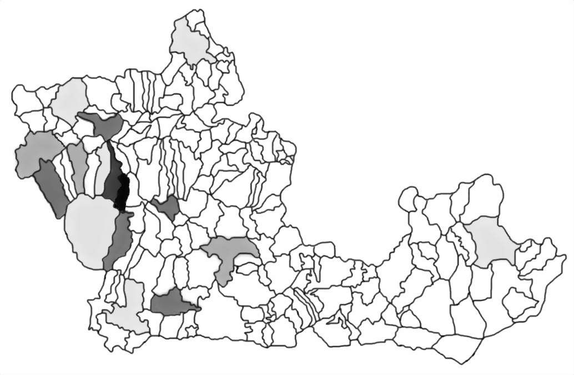
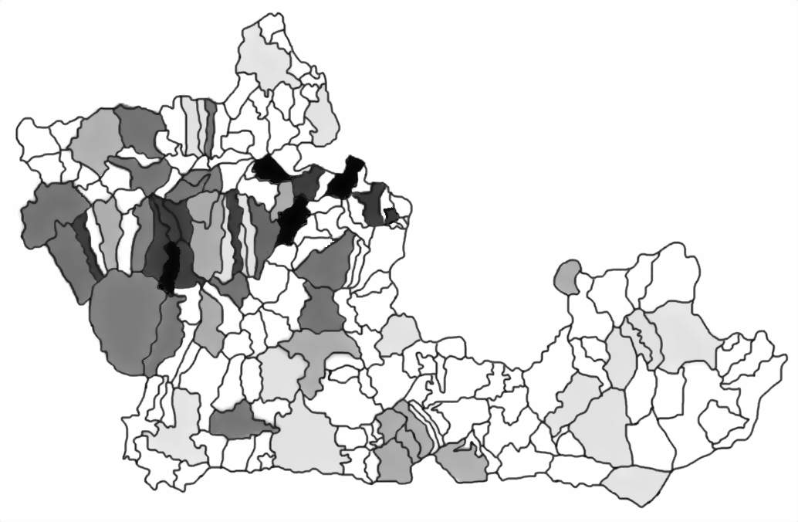
Area of parish affected by parliamentary enclosure
81 to100 per cent
61 to 80 per cent
41 to 60 per cent
21 to 40 per cent
1 to 20 per cent
0 per cent
Fig. 1.2b Proportion of Berkshire parishes affected by parliamentary enclosure before 1816
Fig. 1.2a Proportion of Berkshire parishes affected by parliamentary enclosure before 1793
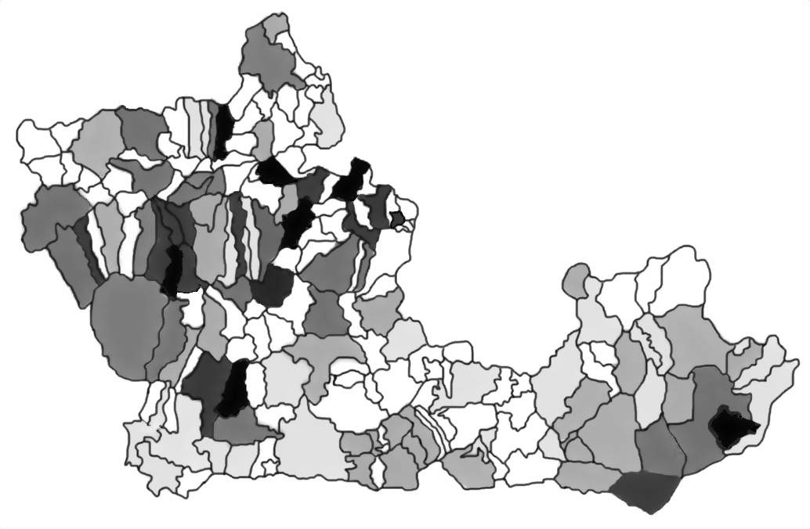
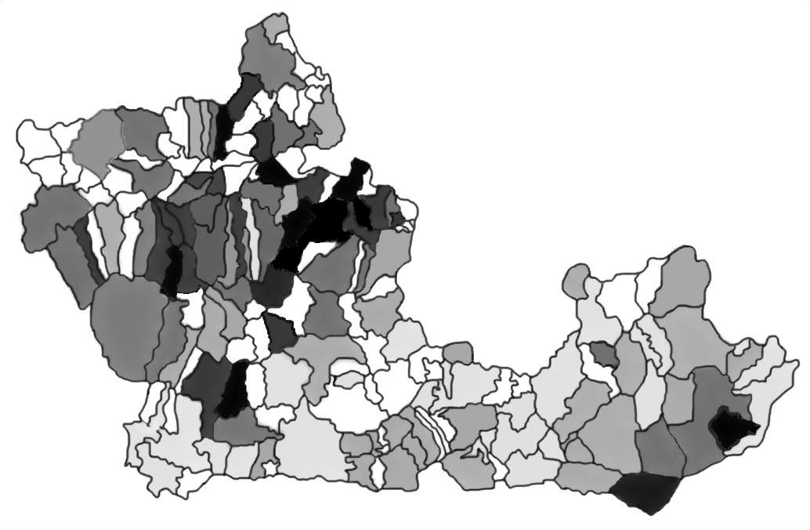
Fig. 1.2c Proportion of Berkshire parishes affected by parliamentary enclosure before 1830
Fig. 1.2d Proportion of Berkshire parishes affected by parliamentary enclosure before 1885
1724 agreed to plant the fallow with peas ‘for the better maintenance of cattle and sheep.’ Vetches and other pulses were also grown in the hitched land in the parish. However, even though such measures increased the potential of the open field, farmers lacked the flexibility of land held in severalty. As long as farming decisions were made by the whole community, the individual did not have the option to suit his cropping to the varied conditions on the holding or in the marketplace. The solution was to enclose the land and farm in severalty.

Parliamentary enclosure in the old county of Berkshire

Characteristically the enclosure pattern in the pre-1974 county of Berkshire fits between that in the Midlands, where parliamentary enclosure was the dominant form of enclosure, was largely completed in the years between 1765 and 1780, and mostly affected the arable open fields, and that in the south of England where other forms of enclosure were more widely used and where more waste and common land remained to be enclosed between 1793 and 1815 by act of Parliament. The enclosure pattern for the county is an interesting combination of the two regions in a number of ways. Like the southern counties, the main wave of enclosures took place during the wars with France at the beginning of the nineteenth century. The maps in figs. 1.2.a-d show the temporal spread of parliamentary enclosure activity in the county at the end of each major phase of activity identified by Turner. During the 1793-1815 period over half, 57.4 per cent, of the area in Berkshire affected by act of Parliament was enclosed. Another 21.4 per cent was enclosed between the first act in the county for Sunningwell in 1723 (no award has yet been found for this enclosure) and 1793, 5.7 per cent between 1816 and 1829, and the final 15.5 per cent was enclosed between 1830 and the award for Steventon in 1885.

In the proportion of the county enclosed by act of Parliament, the Berkshire enclosure pattern fits more closely to the enclosure pattern found in the Midlands. In the south non-parliamentary enclosure was generally used to end communal husbandry. In Hampshire to the south of Berkshire just 16.8 per cent of the land was enclosed by the authority of Parliament.

The county was the twenty-fourth out of forty-three counties in terms of the density of enclosure through act of Parliament. Oxfordshire to the north was ranked first with 54.3 per cent. The density for Berkshire was calculated by Tate and Turner at 34.1 per cent of the surface area. This, however, has recently been revised by Wordie to 34.9 per cent. Wordie’s calculation makes Berkshire with the neighbouring county of Buckinghamshire joint twelfth most densely enclosed county. The maps at figs. 1.2.a-d also demonstrate the density of parliamentary enclosure in each period. The northwestern area of the county where it borders Oxfordshire was, as would be expected, the most densely enclosed. To the east of the county are the Crown estate including the Windsor Forest. The 1813 enclosure of the Forest involved land in fifteen parishes and was the largest single award in the county. The Crown was awarded 6665 acres and another 11,812 acres of non-crown land was awarded in thirteen of the fifteen parishes. This massive award was largely responsible for the relatively high density of enclosure in the area. The south of the county, where it borders onto Hampshire, was least affected by parliamentary enclosure. There were also thirty-three parishes in which no parliamentary enclosures occurred but instead enclosure was non-parliamentary. In another two parishes Parliament was asked to confirm an already existing agreement and no other area within the parish was affected by parliamentary enclosure. Some 4.2 per cent of the county, including Greenham Common, one of the best-known commons in the country, remained open after 1885.

While many areas enclosed by act contained both arable and waste, some enclosure acts dealt only with the enclosure of wastes and commons and not the arable open-fields. Such acts were often used to end common rights on downland sheepwalks so were more often found on the chalks of the southern counties of England. In Hampshire, although enclosure including some arable dominated, 49 per cent of parliamentary enclosures that occurred during between 1793 and 1815 involved only waste and common. In Oxfordshire, on the other hand, approximately a third of parliamentary enclosures occurred during the war period. Of these less than six per cent only involved waste and common. In the Midlands where little common or waste remained to be enclosed, awards invariably included at least some arable. In spite of the areas of downland in the county, the pattern in Berkshire again was more like that found in the Midlands. Of the 161,207 acres calculated by Wordie to have been enclosed by act of Parliament in the county, only 7,253 acres or 4.5 per cent of the enclosed area involved only waste and common.
Table 1.1 Parliamentary Enclosure in the Wantage area
Parish, Tithing, Township, Chapelry | Date of act | Date of award | Area in parish¹  (acres) | Area affected (acres) | Per cent enclosed by act
Letcombe Regis with East Challow | 1801 | 1804 | 3812 | 2434 | 64
West Challow (in Letcombe Regis) | 1801 | 1804 | 739 | 31 | 4
 | 1802 | 1803 |  | 395 | 53
Wantage with Grove | 1803 | 1806 | 4294² | 2370 | 55
Ardington | 1808 | 1811 | 1820 | 1143 | 63
West Lockinge (in Wantage) | 1808 | 1811 | 867 | 31 | 4
East Lockinge | 1808 | 1811 | 3742 | 55 | 3
 | 1845 | 1853 |  | 947 | 25
Charlton (in Wantage) | 1860³ | 1868 | 1884 | 1267 | 67
Total |  |  | 17,158 | 8673 | 51
Notes: 1.Based on Wordie (2000)
2. This does not include the hamlets of West Lockinge and Charlton
3. Date of Order under General Act of 1845
Sources: Enclosure awards
Slightly over one-third of the surface area of Berkshire was enclosed by act of Parliament between 1723 and 1885. The acts normally stipulated that one copy of the award was to be deposited with the incumbent and churchwardens in the parish and a second, enrolled copy, with the county records. This has resulted in a vast archive of important, nationally comparable, material. The words of two of the best-known writers on the subject of English parliamentary enclosures, W.E. Tate and M.E. Turner, best summarise the value and scope of the awards and accompanying maps:
The primary purpose of the awards was at once to achieve and to register the change from the ancient methods of husbandry, the use of open field arable land, of common meadow, and of common pasture… to the modern system of land ownership, tenure, and cultivation ‘in severalty’. But the awards have much more than merely legal or agricultural interest and importance. They form the best, and in many cases the only, source of accurate information as to the distribution of land ownership in English villages two centuries ago. They are full of useful information as to the types of land tenure prevalent in the different district. In perhaps half the villages of the country they serve as ultimate title-deeds to a great part of the land, both that belonging to ordinary proprietors, and that allotted to rectors, vicars and lay impropriators in lieu of tithe and glebe. They record the lands forming the endowments of ancient village charities and schools. They are an authority for information as to the course and breadth of the highways, the existence of footpaths, bridle ways, and rights of way, and the courses, breadths and liability for cleansing of most of the surface drains. The awards, and the plans which are generally appended to them, register the ownership of hedges and fences. They distinguish between titheable and non-titheable lands…. They specify the allotments of land for public purposes, generally to the parish Surveyors of Highways for use as parish gravel pits.
Their value is such that in 2002 the Berkshire Record Office received a grant from the New Opportunities Fund to make the key enclosure documents – the awards and the maps – available to a wider public. This was to be done by scanning the archives and putting them onto a website specifically created for the purpose – www.berkshirenclosure.org. Berkshire is the first county to have made the enclosure awards is hoped that this resource will be widely and profitable used.

Enclosure in the Wantage area
The New Opportunity Fund also made funds available for a nine-month research project on parliamentary enclosure and its impact on the landscape. This was intended to illustrate not only the importance of this aspect of enclosure, but also the types of material available for anyone interested in exploring the enclosure history of a Berkshire parish. Four parishes in northwestern Berkshire – Letcombe Regis with the hamlets of West and East Challow, Wantage with Grove, Charlton, and West Lockinge, East Lockinge with Betterton and West Ginge, and Ardington, were chosen to form the basis of a more in-depth study of the impact of enclosure on the landscape.

The area was typical of the county as a whole and even more so of north-western Berkshire. Just over half, 51 per cent, of the area of the four parishes was enclosed by act of parliament. Almost three-fourths of this enclosure took place during the early years of the nineteenth century; the rest was in the period after 1830 (see Table 1.1). The archive that survives to be used for the study is typical of the type of documents that are available for most areas in the county. There is at least one enclosure award and map for each parish. In addition there are a number of good pre-enclosure maps and tithe maps available for the area as well as a range of related archives including enclosure acts, a working map of the enclosure commissioners, commissioners’ minutes, abstracts of claimants, and evidence of failed enclosure attempts. This material is supported by estate material – maps, deeds, leases, surveys, terriers, and correspondence – as well as some manor court records. Finally the area contains a variety of elements that help to illustrate the impact of enclosure on the landscape. The parishes are long and narrow, stretching from the Vale of the White Horse southwards up onto the Berkshire Downs. Each therefore has a wide range of soils from heavy clay best suited to grazing in the north, poor light chalks used as sheepwalk in the south, and good loams in the central parts of the area.

Enclosure and the Landscape

In order to understand the impact of parliamentary enclosure on the landscape we need to have some knowledge of what was there before. Chapter Two explores the open and common fields of the region before any enclosure took place. Half of the land in the four parishes was still farmed in this way until the early years of the nineteenth century. The large open fields of the arable and the meadow along with the unimproved waste and common created a landscape quite unlike that after enclosure. However, the men appointed to carry out parliamentary enclosure were not given a blank sheet on which to reshape the landscape for just under half of the area was already enclosed. Chapter Three considers non-parliamentary enclosure. Such enclosures were sometimes very similar in nature and impact to enclosures by act of Parliament. Others affected only small areas, and their impact on the landscape was very different from that created
by enclosure through act. Once a decision was made to obtain an act of Parliament to enclose a parish, a team of men – enclosure commissioners – was appointed to carry out the complex process of dividing, allotting, and enclosing the land. They were the architects of the enclosure landscape. Chapter Four considers their work and more generally, the process of enclosure. Chapter Five explores the landscape created by the commissioners. In spite of the growth of urban areas, particularly Wantage and Grove, and the changes that occurred with the creation of an estate village in East Lockinge and Ardington, much of this landscape can still be seen in the Wantage area. Other areas where less radical alteration of the landscape has taken place could undoubtedly provide a richer sample of evidence on the ground. One aim throughout the text is to encourage similar studies in other parishes to further explore the impact of enclosure on the Berkshire landscape.

Chapman and Seeliger, 2002, 10
48 Geo. III c.74 1808); BRO D/EL/01/1
Tate, 1943, 61
Young, 1808, 98; The passing of the 1801General Inclosure Act was expected to reduce this by creating a template on which future acts could be based. However, it is uncertain that the act had much impact on cost of enclosure.
Caird, 11
Mavor, 137
McCloskey, 1972, 19
Norden, 99; Mavor,137 & 492; Chapman & Seeliger, 2002, 19-20; Allen, 1982, 937-53 (argues against a rise in efficiency at enclosure but instead found that the open fields were equally efficient)
Turner, Beckett, Afton, 201-2; Chambers and Mingay, 1966, 8; Tate, 1967, 154
Turner 1980, 32, 221
Turner 1980, 180-1
Turner 1980, 35
Turner 1980, 66
Hoskins, 1957b, 94-5
Northampton Record Office G 3883
Hoskins, 1950, 140-1
Leicestershire Record Office DE66/4350, DG8/24; Bedfordshire Record Office BO 1326
Turner, 1980,143; Hoskins, 1957, 238-40, Thirsk, 1954, 224
Turner 1980, 71
Turner 1980 71, 79
Turner 1980, 63-93
BRO D/EW E9
BRO D/EPb E52/1 and E53
Havinden, 1961,79
Hampshire Record Office 4M53/107/1; 5M50/2323; 149M89/R4/6039
BRO D/EBy E70
BRO D/EWe E2
Turner, 1980, 194
Turner 1980, 180-1
Wordie xxv
Wordie, xxiii-xxiv
Wordie, xxix
Turner, 1980 81
Wordie, xxv
Tate and Turner, 1978, 39

